Test Case: tc003_SPX_Dev5_Crear_Requisicion_Spot_Tipo_Cobro_CC_Urgent
Step 1 - Enter username and password and click to button Enter : Credentials Entered
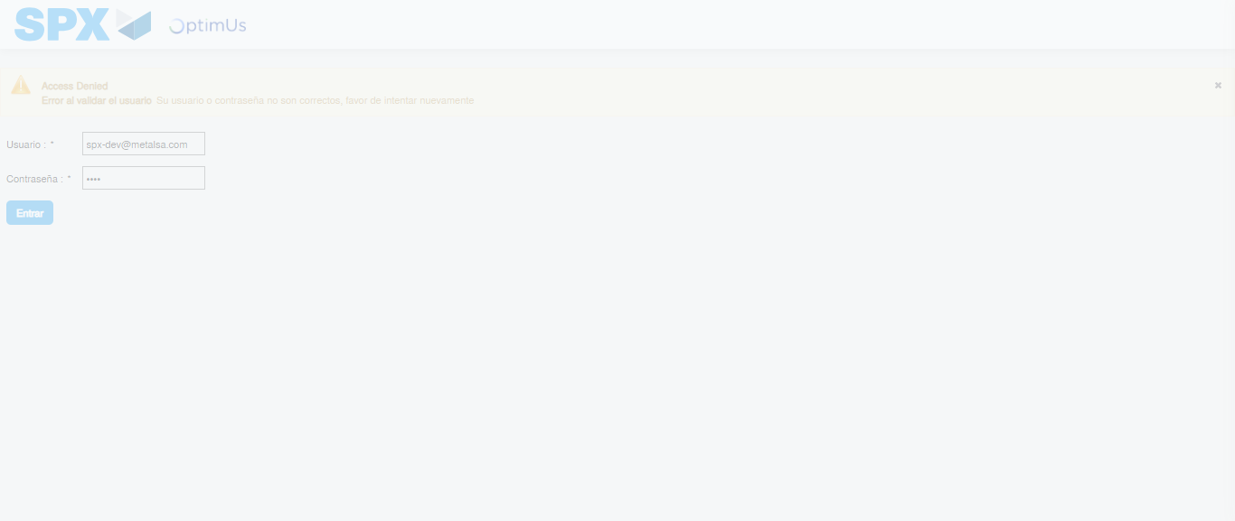Image file-name: QC_Testing-tc003_SPX_Dev5_Crear_Requisicion_Spot_Tipo_Cobro_CC_Urgent-1785344896025

Step 2 - Select to UEN and Access to Spot Buy Requisitions : UEN Correctly selected and Correct access
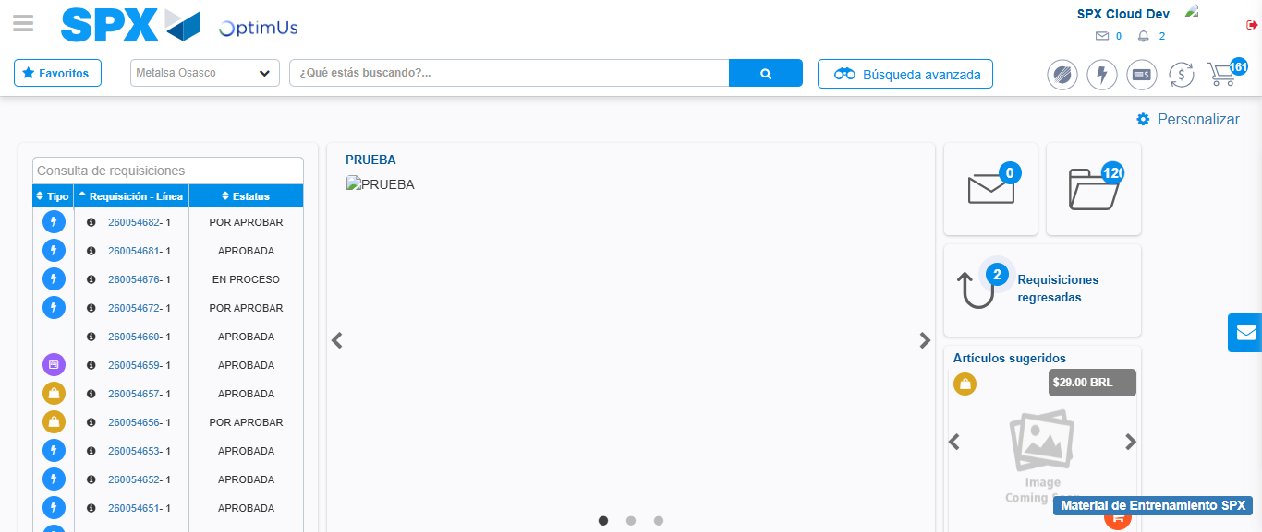Image file-name: QC_Testing-tc003_SPX_Dev5_Crear_Requisicion_Spot_Tipo_Cobro_CC_Urgent-1785344921578

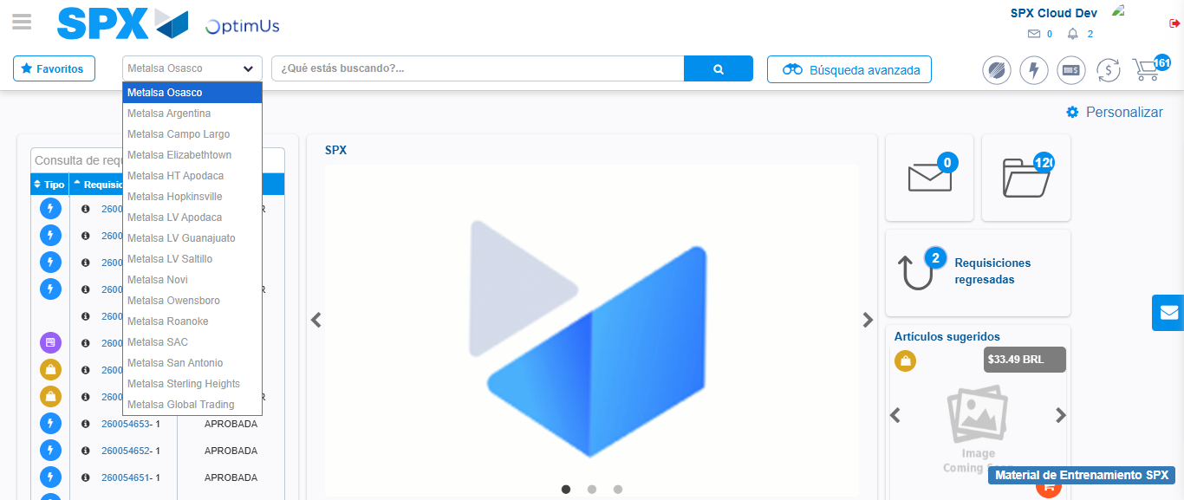Image file-name: QC_Testing-tc003_SPX_Dev5_Crear_Requisicion_Spot_Tipo_Cobro_CC_Urgent-1785344924347

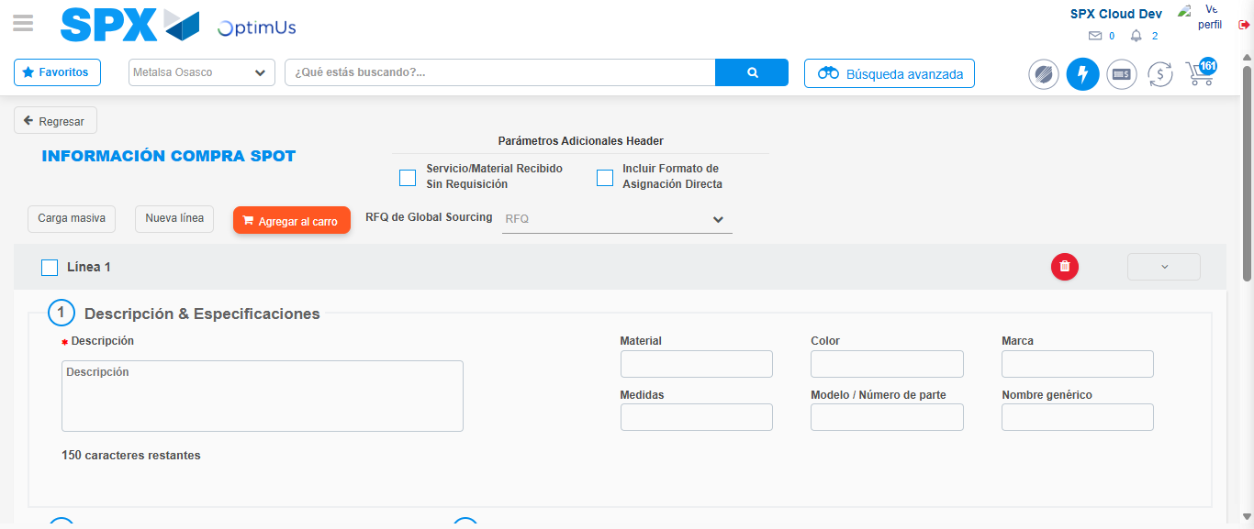Image file-name: QC_Testing-tc003_SPX_Dev5_Crear_Requisicion_Spot_Tipo_Cobro_CC_Urgent-1785344953194

Step 3 - Data Capture Spot Buy Requisition: Data captured correctly
Image file-name: QC_Testing-tc003_SPX_Dev5_Crear_Requisicion_Spot_Tipo_Cobro_CC_Urgent-1785344953431

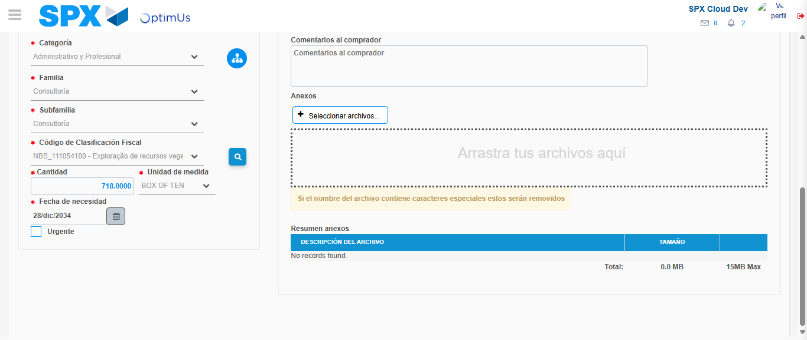Image file-name: QC_Testing-tc003_SPX_Dev5_Crear_Requisicion_Spot_Tipo_Cobro_CC_Urgent-1785344969682

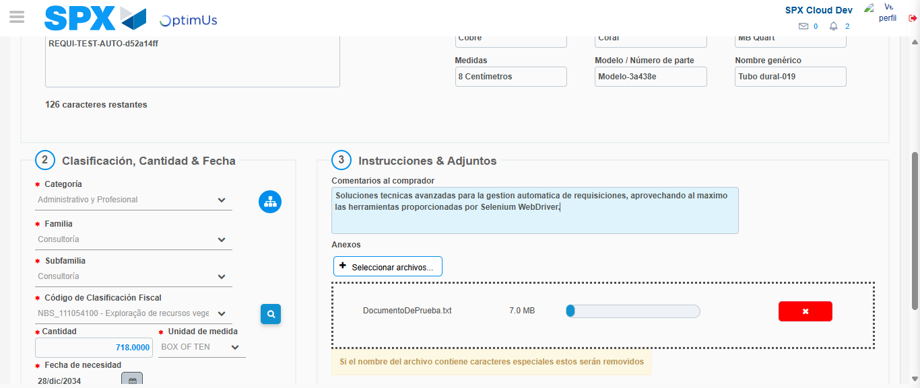Image file-name: QC_Testing-tc003_SPX_Dev5_Crear_Requisicion_Spot_Tipo_Cobro_CC_Urgent-1785344970674

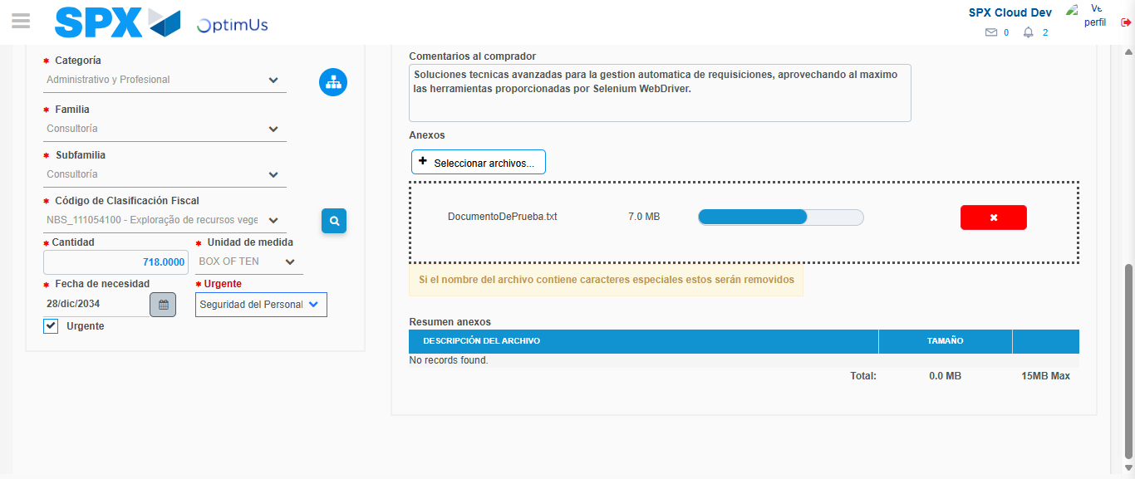Image file-name: QC_Testing-tc003_SPX_Dev5_Crear_Requisicion_Spot_Tipo_Cobro_CC_Urgent-1785344974580

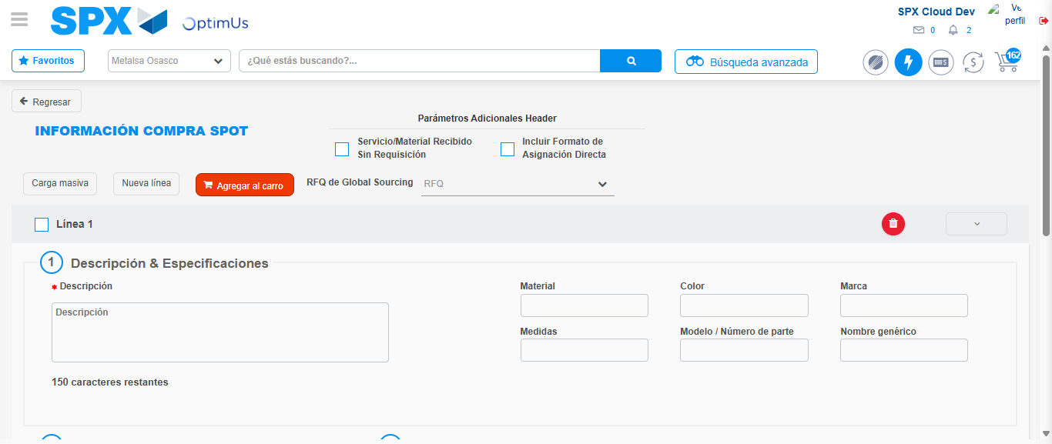Image file-name: QC_Testing-tc003_SPX_Dev5_Crear_Requisicion_Spot_Tipo_Cobro_CC_Urgent-1785344981529

Step 7 - Return to Main Page SPX : Return to Main Page SPX
Image file-name: QC_Testing-tc003_SPX_Dev5_Crear_Requisicion_Spot_Tipo_Cobro_CC_Urgent-1785344921578

Image file-name: QC_Testing-tc003_SPX_Dev5_Crear_Requisicion_Spot_Tipo_Cobro_CC_Urgent-1785344924347

Image file-name: QC_Testing-tc003_SPX_Dev5_Crear_Requisicion_Spot_Tipo_Cobro_CC_Urgent-1785344953194

Image file-name: QC_Testing-tc003_SPX_Dev5_Crear_Requisicion_Spot_Tipo_Cobro_CC_Urgent-1785344983808

Image file-name: QC_Testing-tc003_SPX_Dev5_Crear_Requisicion_Spot_Tipo_Cobro_CC_Urgent-1785344983998

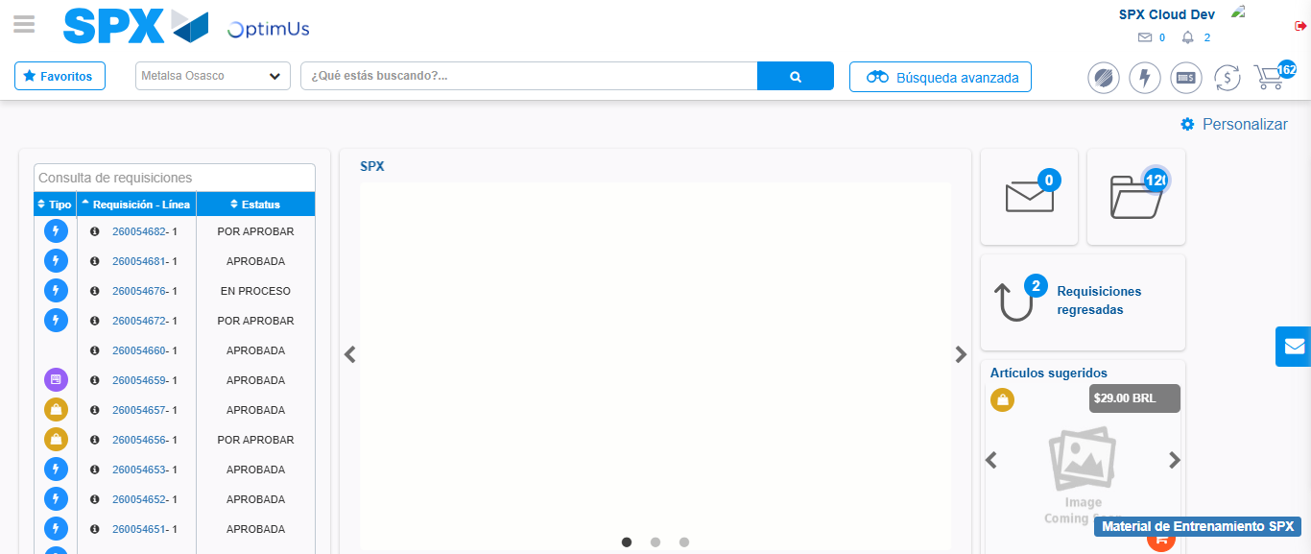Image file-name: QC_Testing-tc003_SPX_Dev5_Crear_Requisicion_Spot_Tipo_Cobro_CC_Urgent-1785345005365

Step 8 - Log Out : Log Out SPX
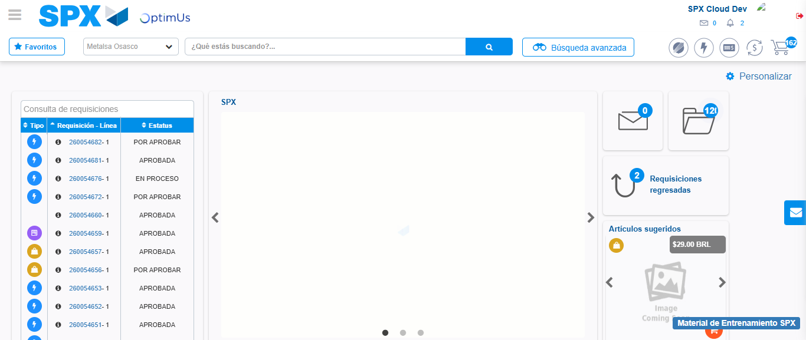Image file-name: QC_Testing-tc003_SPX_Dev5_Crear_Requisicion_Spot_Tipo_Cobro_CC_Urgent-1785345005690

